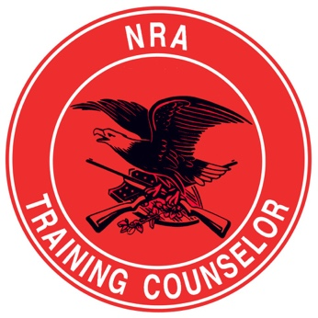
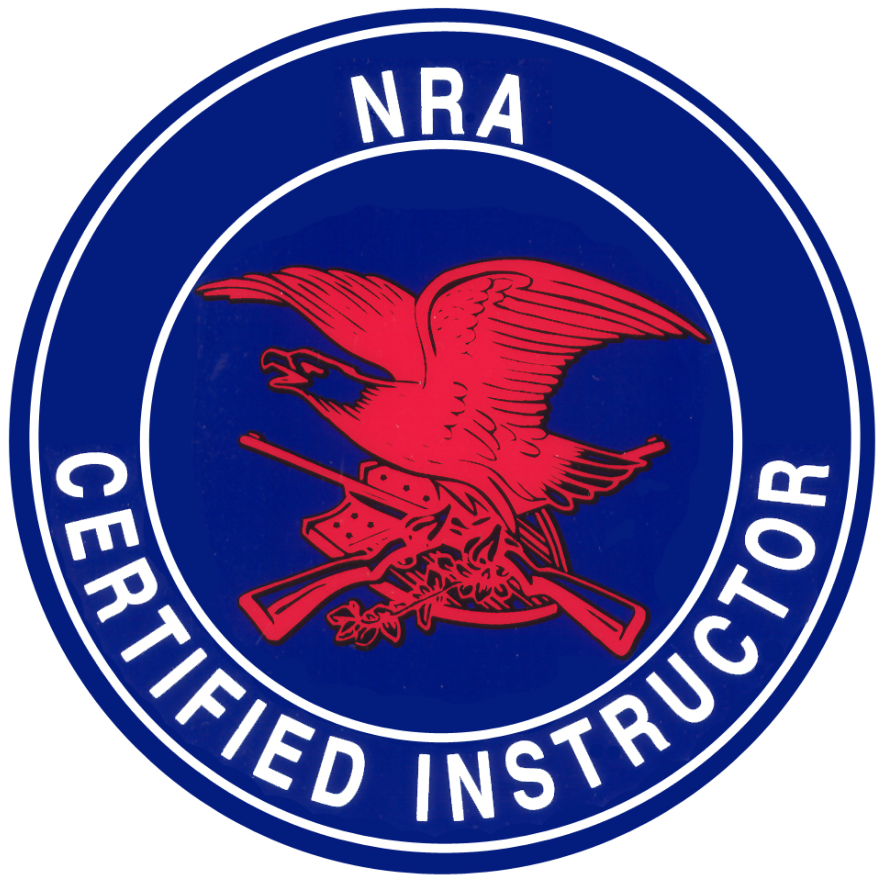
salomon Firearms Training, LLC

Founder & CEO: Pierre Salomon
www.SalomonFirearms.com Facebook, IG, YouTube, PS4, SnapChat, Twitter: SalomonFirearms
SFT-Combatives
Unlock the warrior within

~ required GEAR for training ~
- 14oz Boxing Gloves
- 6oz MMA Gloves (Sparring Gloves)
- Hand Wraps (180”)
- Mouth Guard & Case
- MMA Protective Head Gear
- Athletic Shorts (No longer than knee length)
- Cup/Groin Protector & Female Pelvic Protector
- MMA Knee Pads & Shin Guards (Soft/padded)
- Summer & Winter Running Gear (Under Armour)
- MMA Elbow/Knee/Ankle braces (Light Cloth)
- Jump Rope
- Running Shoes
- Boxing Shoes
- BJJ GI
- Sandals/Flip Flops

