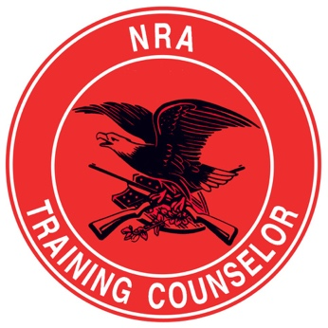
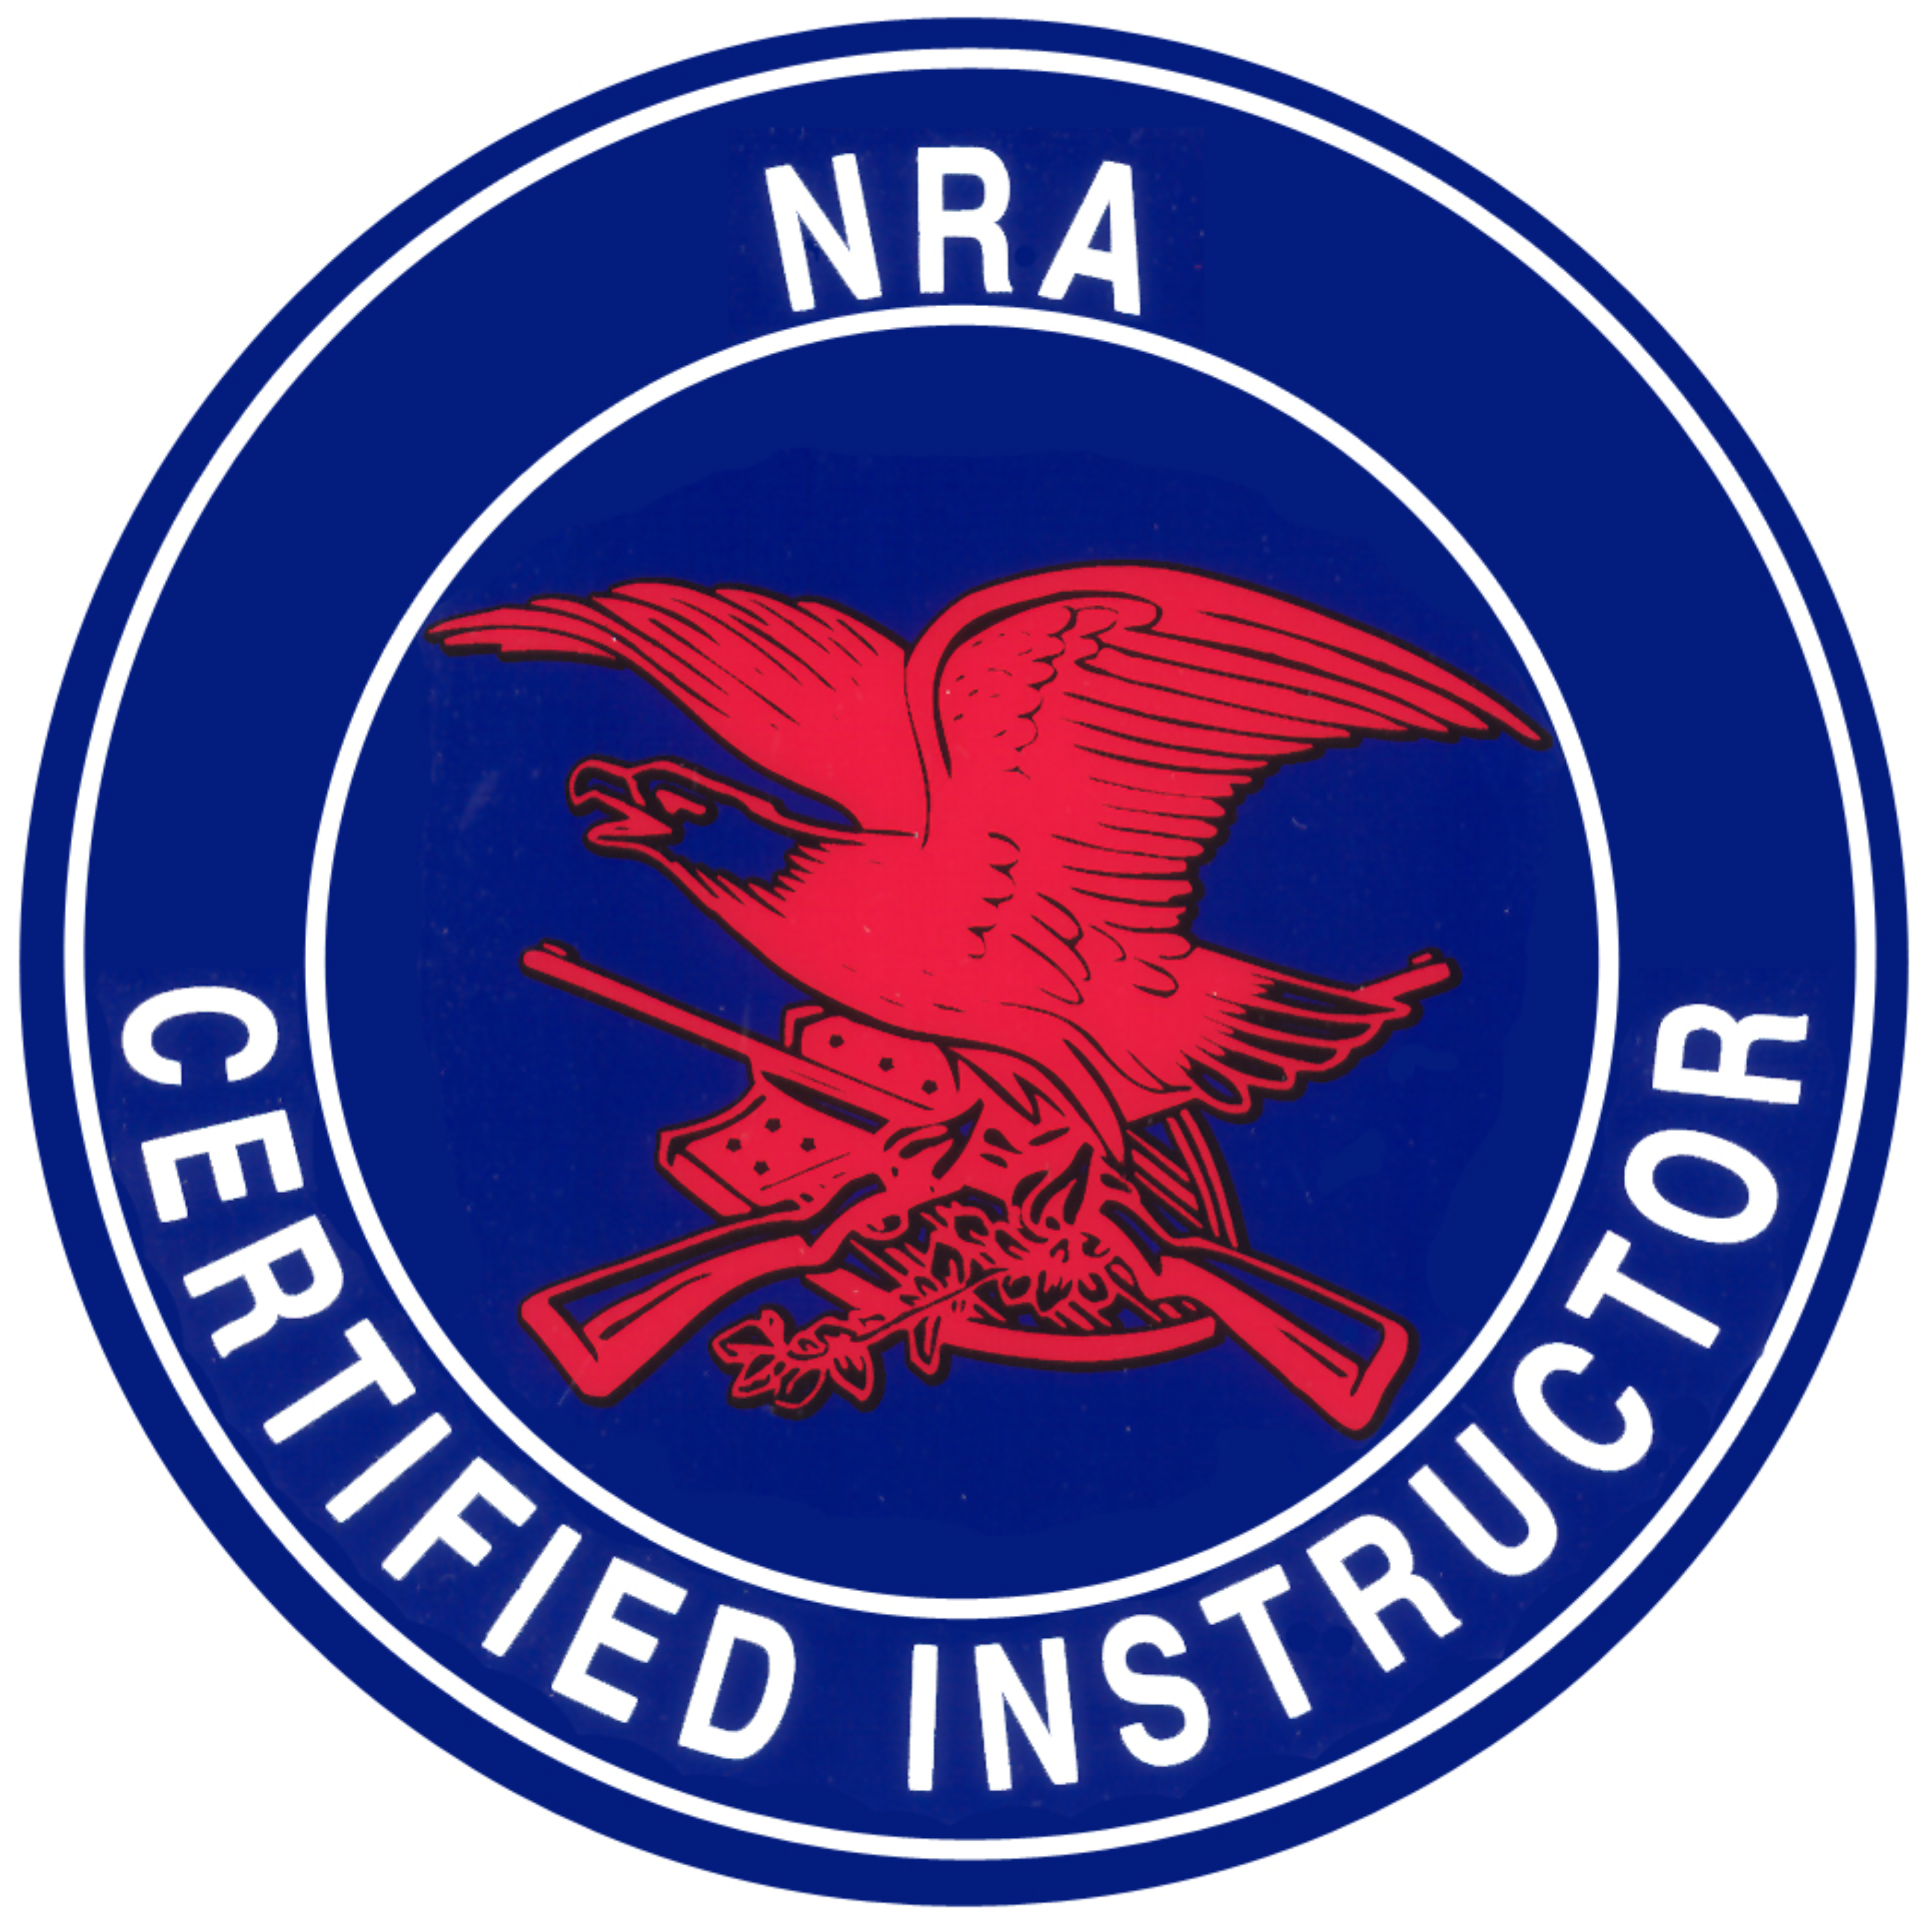
salomon Firearms Training, LLC

Founder & CEO: Pierre Salomon
www.SalomonFirearms.com Facebook, IG, YouTube, PS4, SnapChat, Twitter: SalomonFirearms
SFT-Combatives
TAKE CARE OF YOUR MIND, BODY, & SOUL

~ Stretches & RotationS ~

Stretches & Rotations (SR) start from your head downwards, in a systematic manner. All SR will last 15 seconds or 10 rotations. After completion of the entire set, students have 5 minutes to stretch on their own.

- Neck Rotations w/Side Pauses
- Shoulder Rotations
- Arm Rotations
- Elbow Rotations
- Wrist Rotations
- Finger Rotations
- Over Head Arm & Abdominal Stretch
- Triceps Stretch
- Chest Stretch
- Bent Arm Stretch
- Hip Rotations
- Knee Rotations
- Standing Calf Stretch
- Kneeling Thigh Stretch
- Split Stretch
- Sitting Lower Back Stretch
- Sitting Groin Stretch
- Sitting Calf Stretch
- Sitting Ankle Rotation
- Supine Butt Stretch
- Sitting Cross Over Calf Stretch
- Supine Full Body Stretch
- Prone back stretch
- Prone Full Body Stretch

** Classes begin & end with SR**

