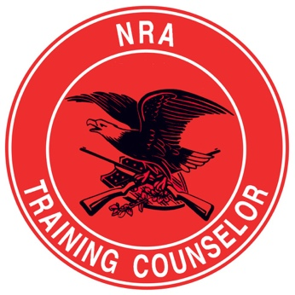
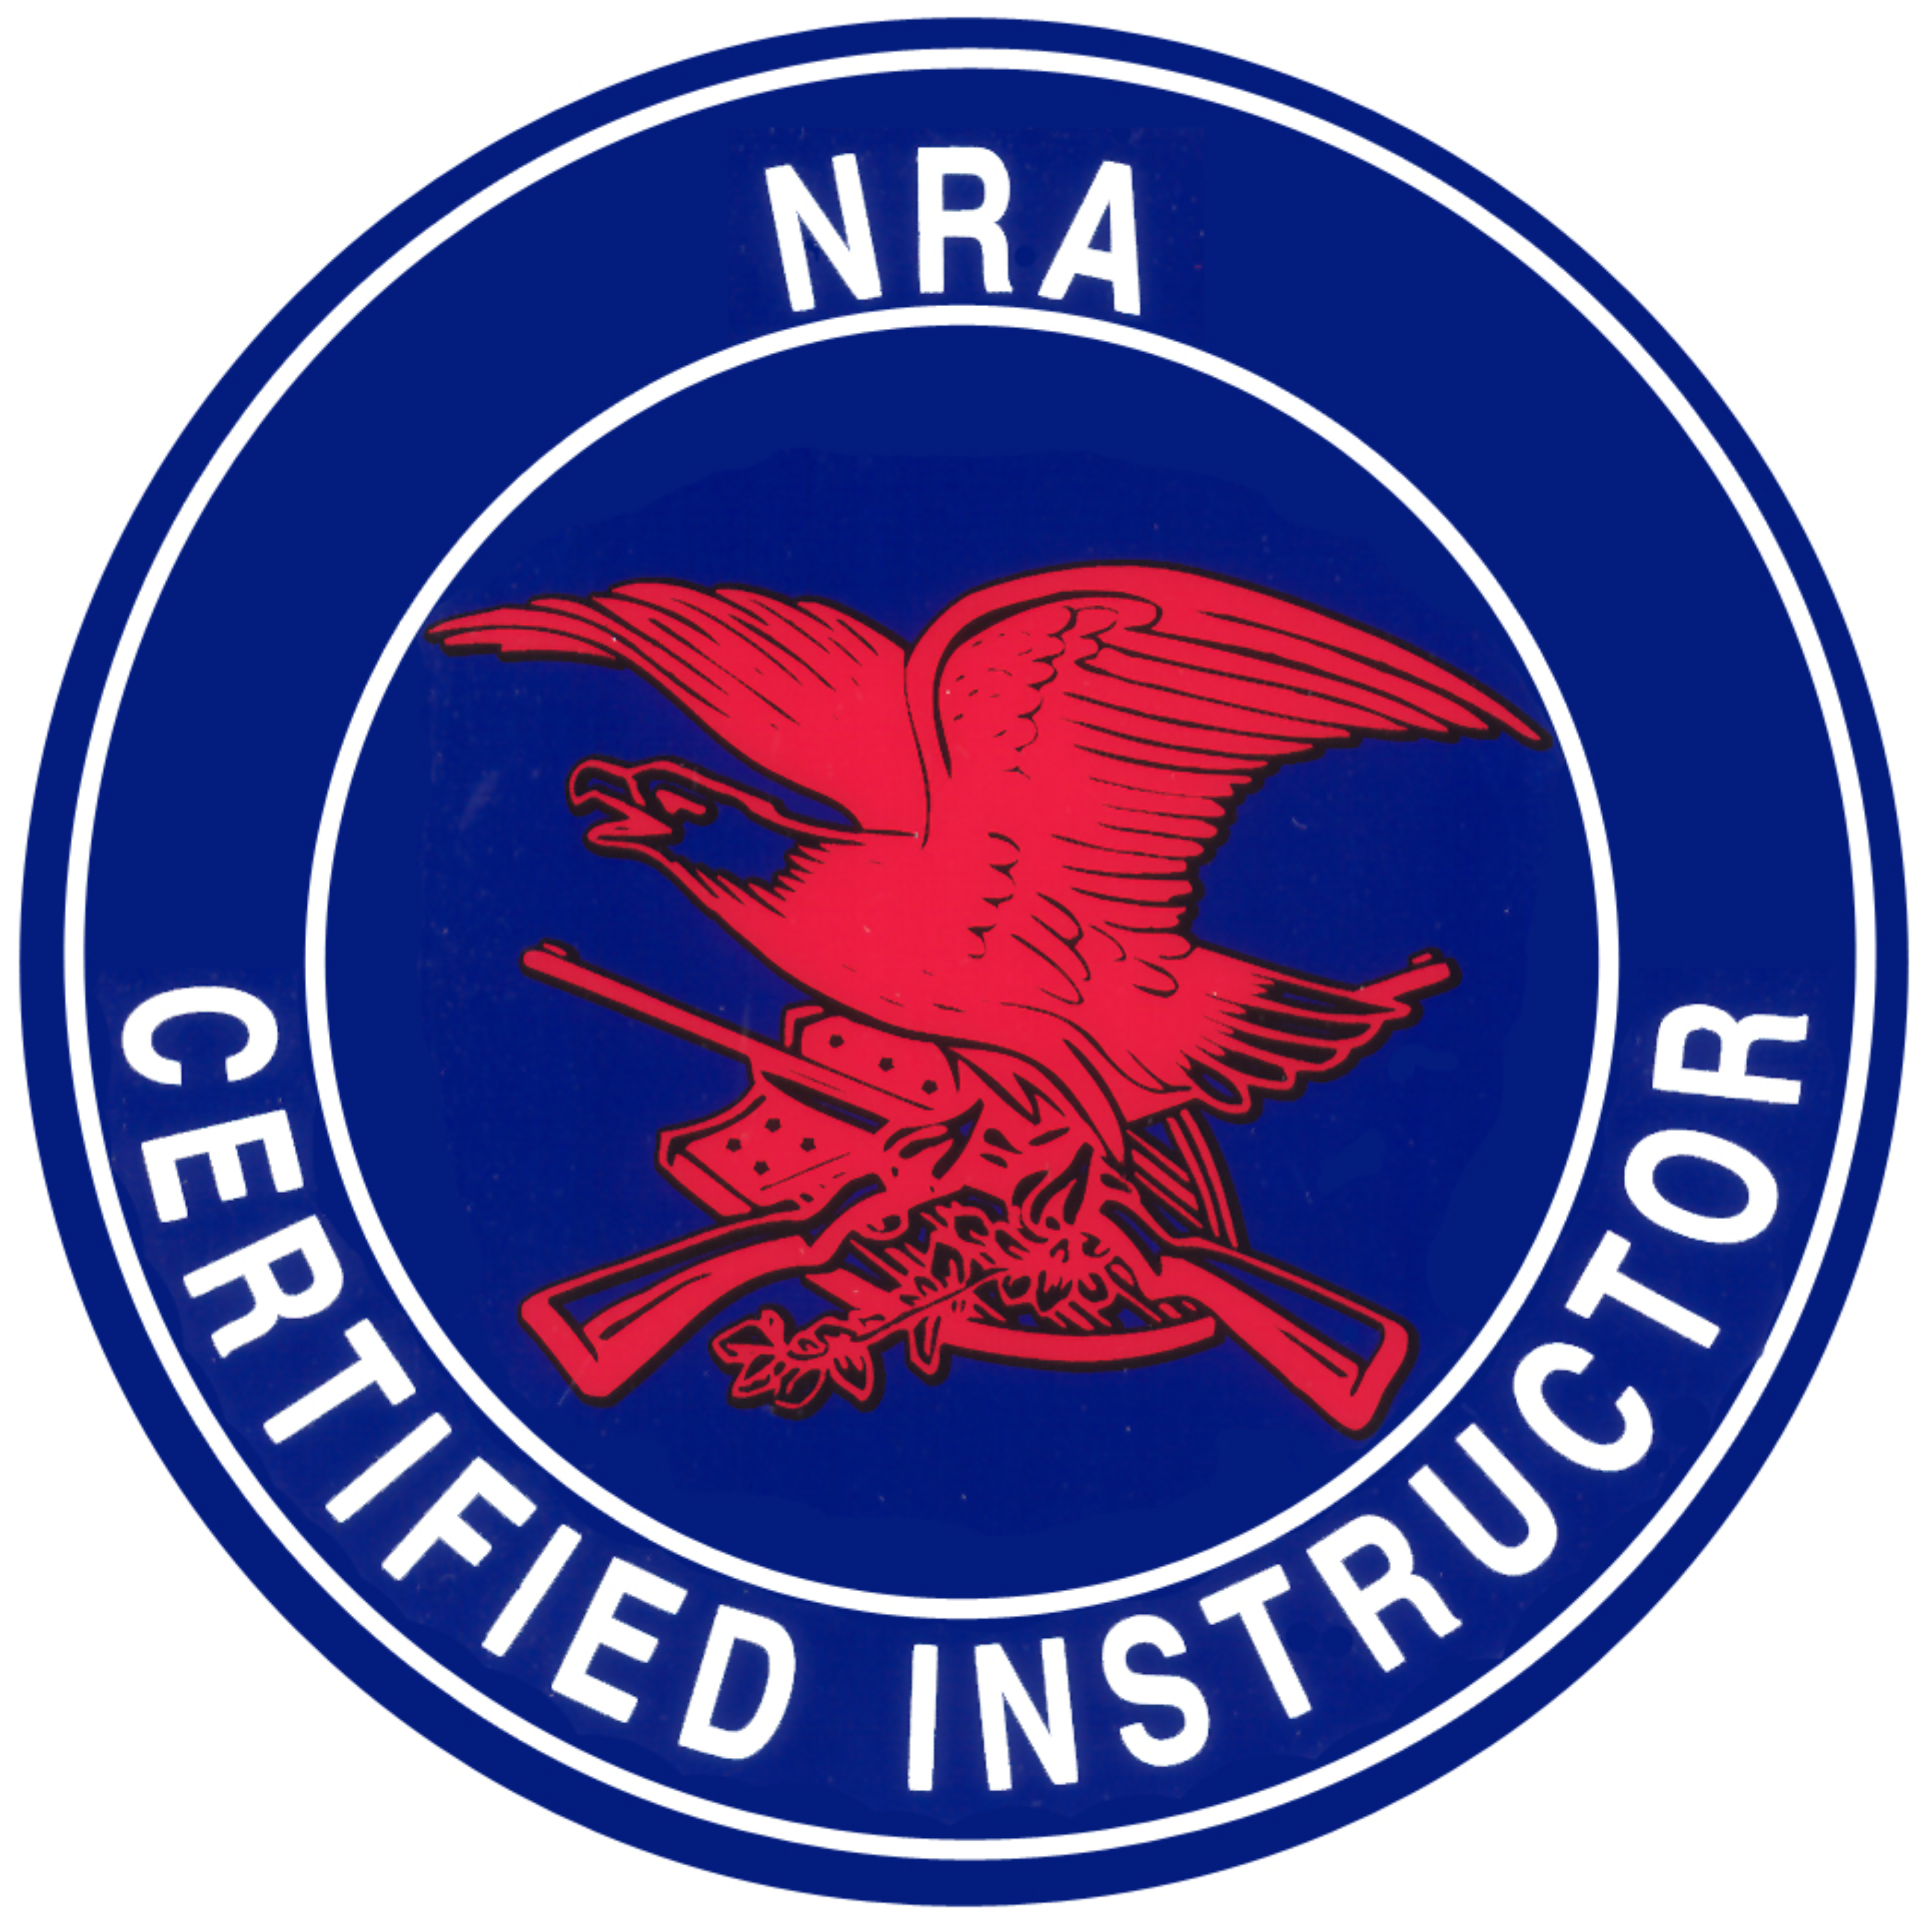
salomon Firearms Training, LLC

Founder & CEO: Pierre Salomon
www.SalomonFirearms.com Facebook, IG, YouTube, PS4, SnapChat, Twitter: SalomonFirearms

SFT-Combatives
Safety First! Everyone is responsible for safety!

~ SAFETY Rules FOR Training ~
- No eye gouging, biting, scratching, head-butts, pinching, hair pulling, spitting, tickling.
- No grabbing, twisting, bending, pulling, or breaking of fingers. No digging of nails into skin.
- No spiking (picking someone up and slamming them on the mats).
- No heelhooks (twisting or jerking of the foot, knee, or ankle).
- No neck cranks, strikes to the groin area, or strikes to the breast area.
- SAFETY IS OUR PRIMARY CONCERN: If we are not Safe & Healthy, we cannot train. SFT-C is VERY DANGEROUS! It is important that we respect and follow the safety rules & regulations, to ensure we do not sustain or aggravate any avoidable injuries.
Tapping Out: Tapping out is the formal notification to your Training Partner (TP) that you are submitting (giving up) to their technique/pressure, signaling you have met your safety threshold, or want the session to end, for any reason. You generally tap at least 3X in rapid succession with your hands, to indicate that you want the training session to stop immediately.
3 Ways To Tap: 1- Physically tapping your TP hard enough so they can feel it. 2- Physically tapping yourself or the mat loudly so it can be seen and heard. 3- Verbally yelling “TAP” so people can hear.
YOU MUST STOP IMMEDIATELY ANYTIME SOMEONE TAPS!!! FAILURE TO STOP WILL RESULT IN SEVERE INJURY TO YOUR TP & TERMINATION FROM SFT-C!

